Outreach Report for AGM
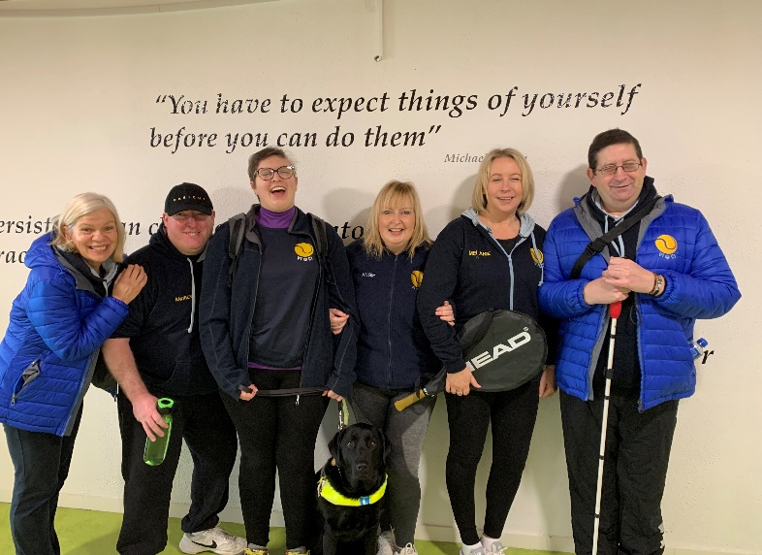
30th November 2020

Up until March 2020 lockdown outreach tennis was providing weekly:
- Blind Tennis every Monday for blind and visually impaired adults.
- Dementia Friendly tennis every Wednesday for those living with dementia and their family members / carers.
- A performance session in Blind tennis for selected adults competing in competition. Players are competing in GB, Ireland, and World competitions.
- Blind Tennis every Saturday for blind and visually impaired (VI) children and their siblings if they wish. Some of these children have complex needs. Their mothers were taking group tennis lessons from scratch alongside them.
All groups came to an end in March with only our adult VI@CI group starting back in May on the same basis as all members though the various stages of return to tennis – singles, then doubles and then back to group/club play training.
VI@CI Diary:
- 8 players played in a winter tournament at Ozone Belfast in December.
- We held a joint Xmas party for all our sighted and VI juniors together. 100 indoor snowballs provided some seasonal fun in the dome.
- Doris Finlay and Brian Lenehan travelled to the GB Nationals. Brian took 1st and Doris 4th.
- We held a Xmas tournament and invited the Coleraine players (who are also coached by Gary) to join us. We had Xmas lunch together in the clubhouse.
- We travelled to Galway in January for a regional competition with all the squad performing well. Andrew McBride took 1st in the Men’s B2 and Mel 2nd in Ladies B2.
- We travelled to Dublin again in February for the Irish Nationals. Doris came first in B4, Brian 1st in B3, making the Irish team. Mel was offered a conditional place in the team following an injury on court. The world games were subsequently cancelled.
- We welcomed 4 new players this year.
- Our players from the VI@CI section were once again integrated into our Internal League competition.

Schools
Outreach delivered tennis in schools in conjunction with Ulster Tennis. This year these grant funded sessions have seen our coaches deliver tennis to St Patrick’s Knock and Gilnahirk PS.

PEACE Grant.
We were approached by Belfast City Council to run this program which is cross community, cross border, and cross sport. Unfortunately, it has been put on hold like so much else.

Other achievements this year
- Brian Lenehan was awarded Disability Sports Personality of the Year
- I was awarded the Belfast City Council Disability Coach of the Year Award.
- Brian Lenehan has taken the GB nationals for 2 years in a row
- Brian and Mel made the Irish team
Development Training
Our coaches and volunteers have taken a course in Autism awareness run by Disability Sport NI, giving us a better insight on court.
I took a Tennis Ireland Assistant Coach qualification
Finance
Financing our groups is incredibly challenging this year. We are limping along. Thank you to our coaches who have given freely of their time over summer. We are currently supported by Sport NI for a short time.
We are actively seeking assistance from any leads!
Thank you.
Thank you to all the club members who show support for our outreach department.
Thank you to our coaching team who have all embraced the outreach projects and deliver time and time again on court, engaging new players and improving the play of our existing groups.
As always, the biggest thank you goes to our dedicated team of volunteers (including some of our coaches this summer) who give so generously with their time.

Jane Mounsey

