CIYMS Tennis Club, 91 Circular Rd, Belfast BT4 2GD

CODE OF CONDUCT FOR CHILDREN/YOUNG PEOPLE
CIYMS Tennis Committee

08
Fall
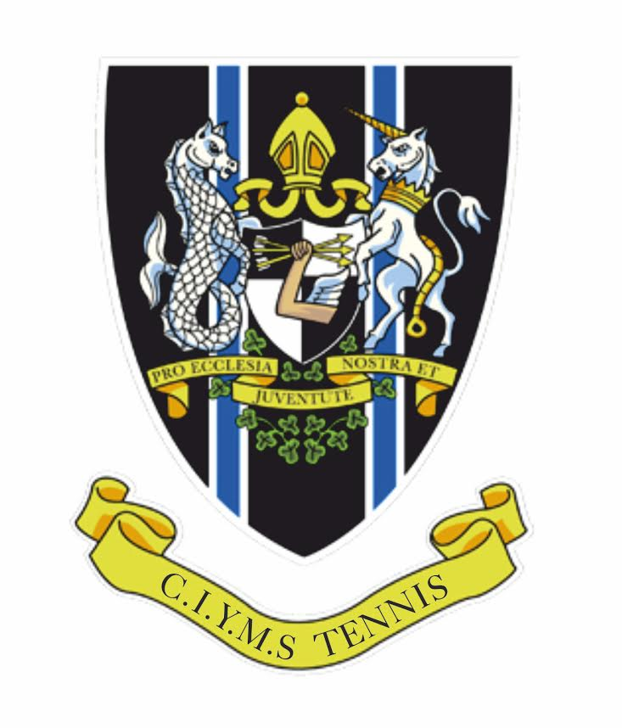

CIYMS CODE OF CONDUCT FOR CHILDREN/YOUNG PEOPLE

cIYMS Tennis Club is fully committed to safeguarding and promoting the wellbeing of all its members. The club believes that it is important that members, coaches, administrators and parents associated with the club should, at all times, show respect and understanding for the safety and welfare of others. Therefore, members are encouraged to be open at all times and to share any concerns or complaints that they may have about any aspect of the club with Junior Co-ordinator and Chair.

Sports clubs for young people should offer a positive experience where they can learn new things in a safe and positive environment.

As a member of cIYMS Tennis Club unsporting behaviour such as throwing rackets, hitting the racket head on the ground or hitting balls at people or fences is not acceptable.

You are also expected to abide by the following junior code of practice:

Children/young people are expected to:

- Make your club a fun place to be
- At all times play fairly and within the rules of tennis. Do not cheat
- Be friendly to all and particularly welcoming to new members.
- Respect opponents, win with grace and lose with dignity
- Wear suitable kit, including footwear whilst on court
- Be supportive and committed to other team members, offer comfort when required.
- Refrain from bullying or use of bullying tactics whilst playing. Challenge or report the bullying of your peers.
- Not get involved in inappropriate peer pressure and push others into something they do not want to do.
- Behave and listen to all instructions from the coach/ club officials
- Take care of all equipment owned by the club/coach leaving the court as you found it
- Respect the rights, dignity and worth of all participants regardless of age, gender, ability, race, cultural background or religious beliefs or sexual identity.
- Refrain from the use of bad language or racial/sectarian references. This includes bullying using technologies like social media or texting.
- Not smoke, consume alcohol or drugs of any kind on club premises or whilst representing the club.

Children/Young people have the right to:

- Be safe and happy whilst playing tennis at CIYMS
- Be listened to, respected and treated fairly
- Enjoy tennis in a protective environment
- Be referred to professional help if needed.
- Participate on an equal basis, appropriate to their ability.
- Experience competition and the desire to win.
- Be protected from abuse by other member or outside sources
- Ask for help

Any misdemeanours and general misbehaviour will be addressed by the immediate coach/ club official and reported verbally to the Junior Co-ordinator and Chair. Persistent misbehaviour will result in dismissal from the club. Parents will be informed at all stages.

Dismissals can be appealed, with final decisions taken by the CIYMS Tennis Club Committee.

This code should be reviewed every two years

Date Agreed by Club Committee ______________

Date for Review __________________

Signature: ………………………………...… Club Chair

Signature: ………………………………...… Club Secretary

